User manual
How to use the software will be explained in the tutorial in the software’s tutorial.
To get to the tutorial, open the software and press the practice button on the home screen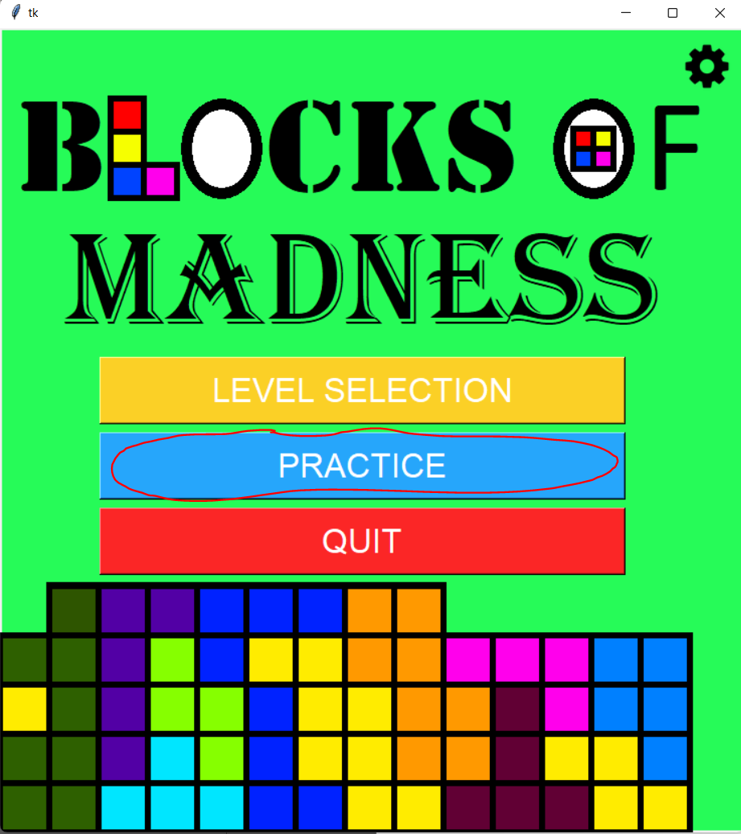
Then press the tutorial button located on the top right of the practice screen.
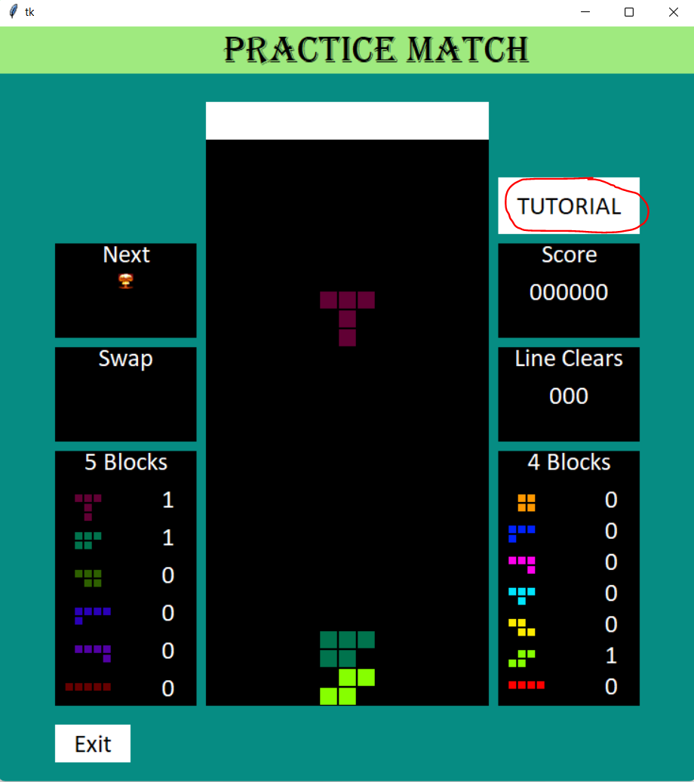
To navigate through the tutorials, press the left or right arrow buttons to move the screens around
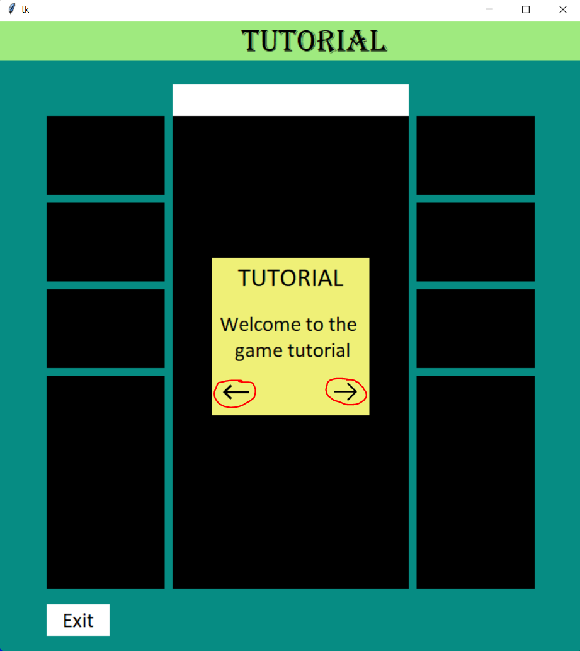

Installation guide
To use the software functionally, there are 4 things that needs to be downloaded: the software file folder, the python files, the python pillow module, and the python pygame module. You should already have the software file folder.
- To download the python files, go to the official website of python at https://www.python.org/.
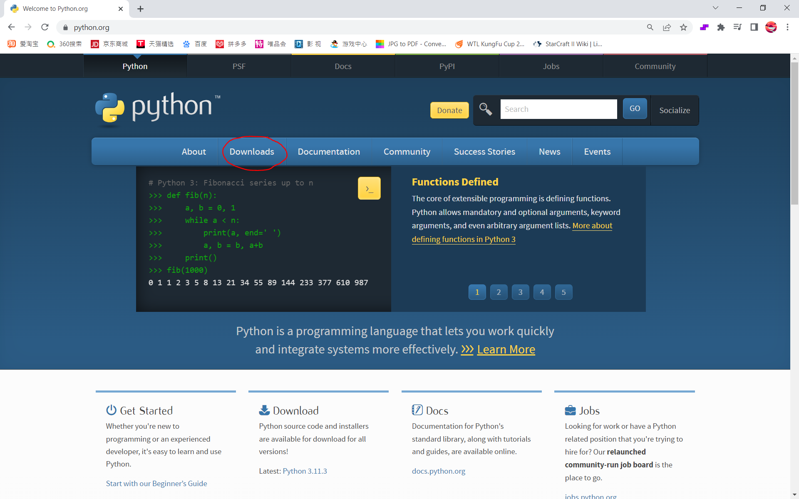
- Click the downloads bar in the toggle menu.
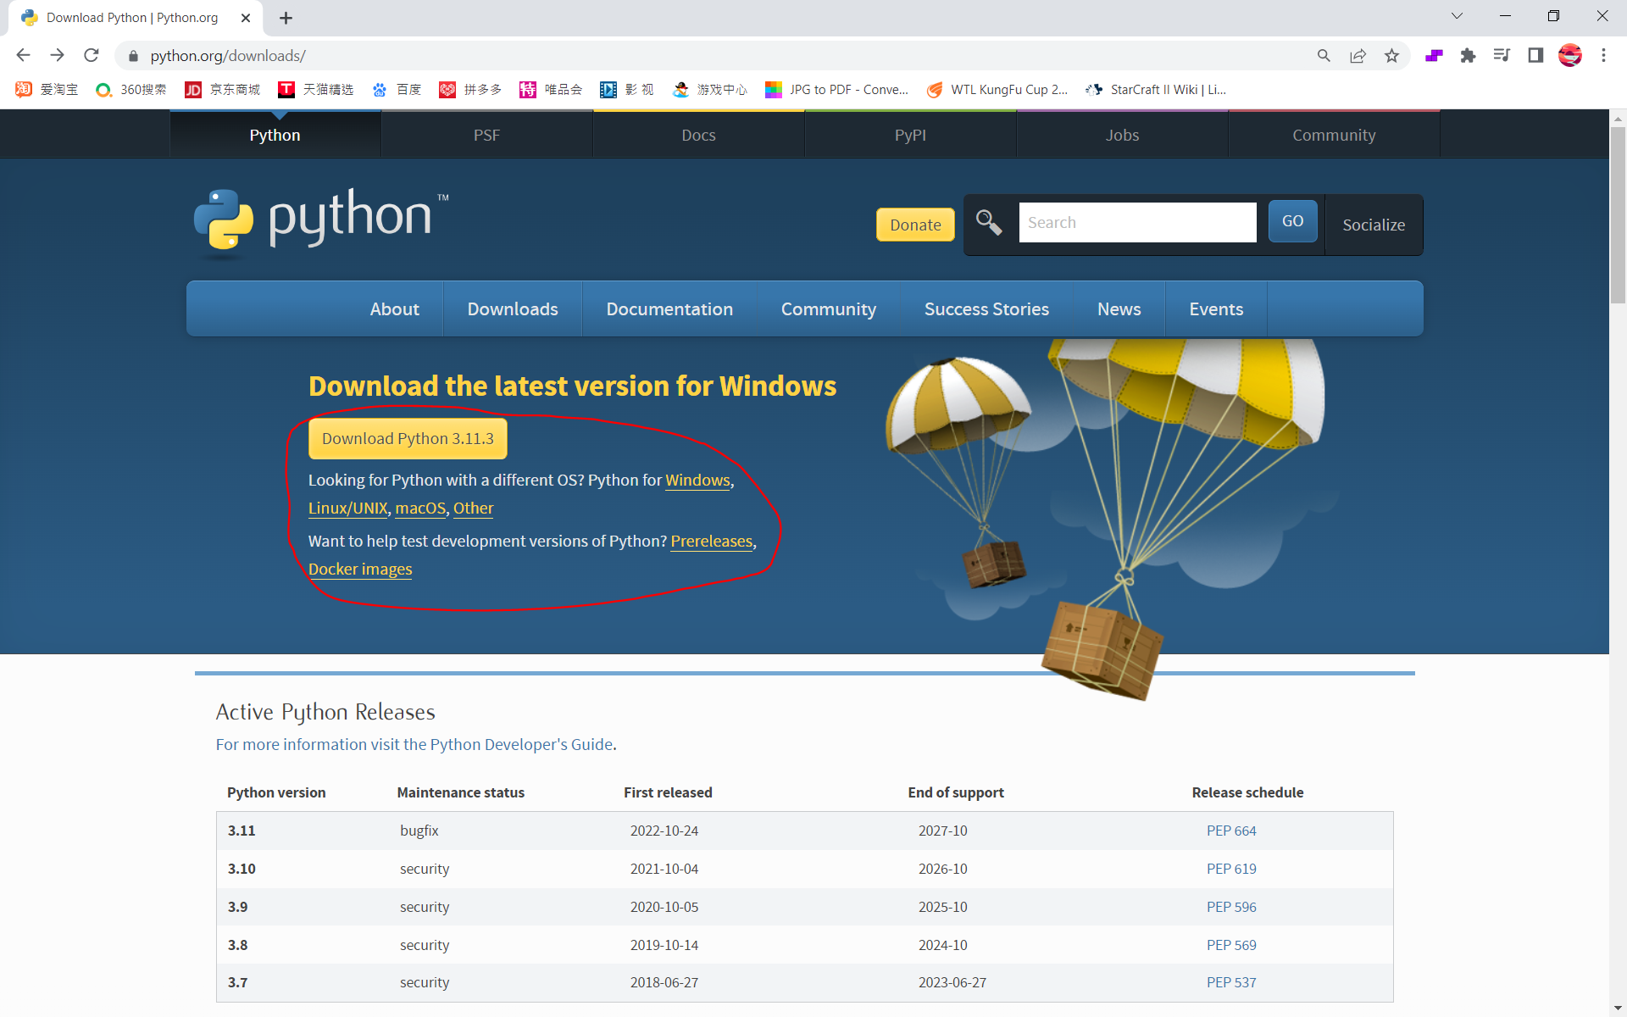
- Choose the type of operating system you have and download the latest version of python.
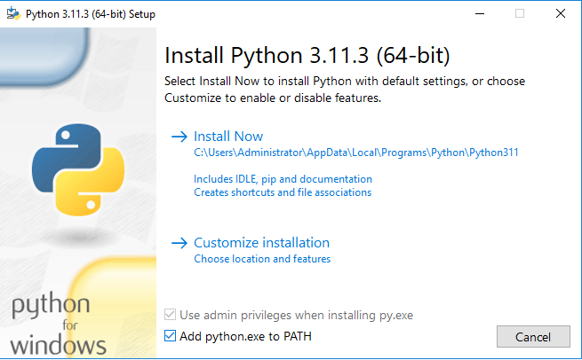

- Open the python set up file and make sure the bottom two boxes are ticked
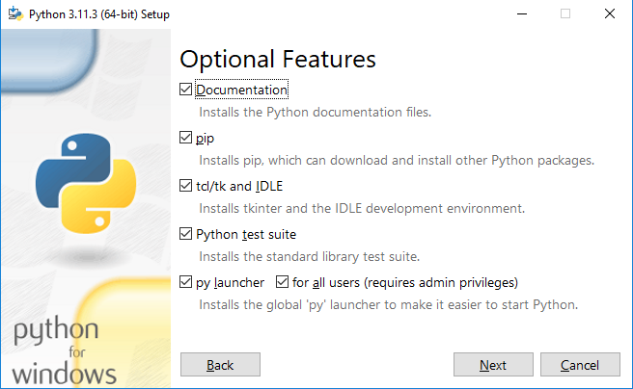
- Choose the customize installation option and make sure the pip and tcl/tk and IDLE and Python test suite boxes are ticked off.
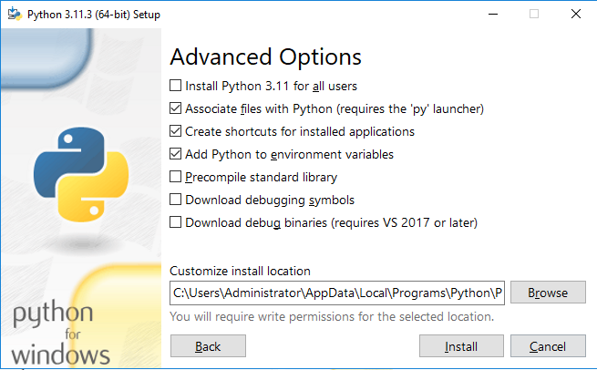
- Choose the location you want to store the python files at.
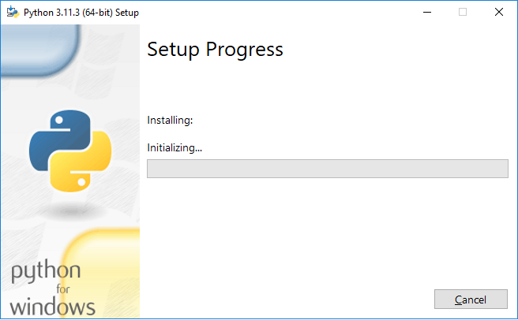
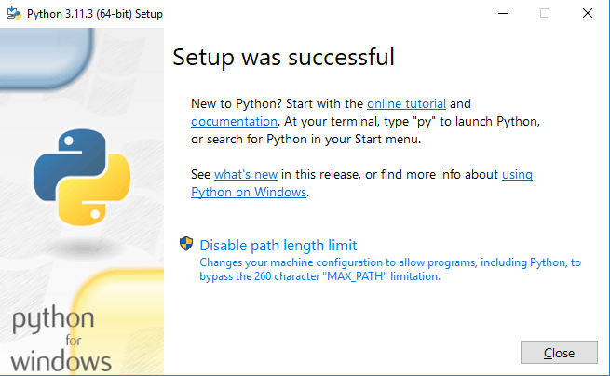

- Install Python and wait until it is finished.
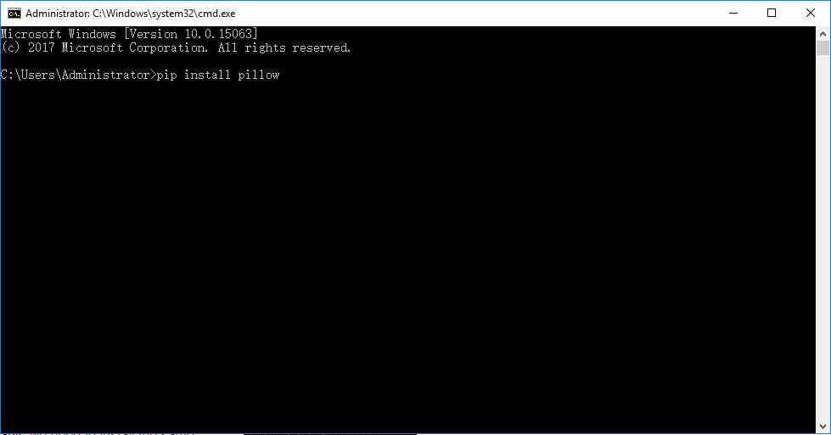
- Open command prompt by searching in the search bar or pressing Win + R and then typing cmd in the run box.
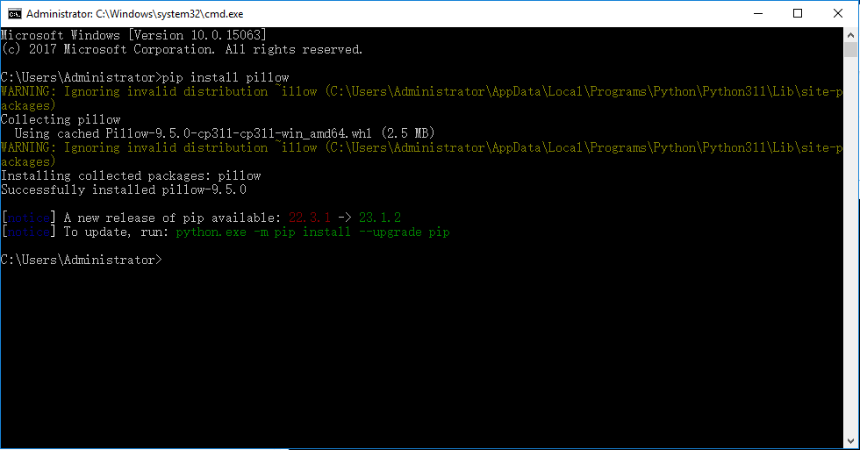
- Type pip install pillow and then enter so you can install the pillow module
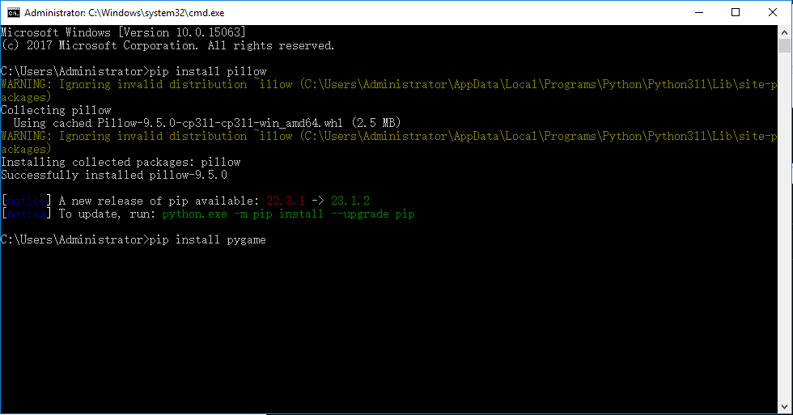
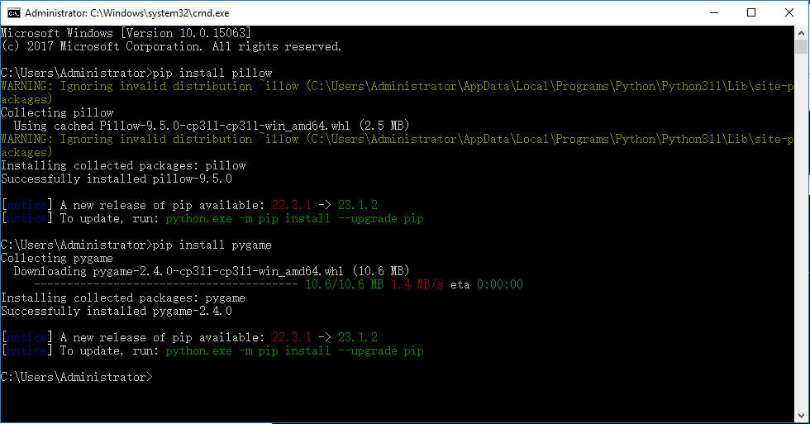
- Type pip install pygame and then enter so you can install the pygame module.
Now you can use the software properly.

